**Security Testing and Vulnerability Analysis of**secure_version

**Introduction:**

The security testing suite for the secure_version project was developed to ensure that the codebase maintains a strong security posture. It combines static analysis with targeted runtime checks to detect common vulnerabilities, including weak RSA keys, unsanitized file paths, unsafe SQL operations, missing signature verification, and potential high-severity issues flagged by tools such as Bandit. These tests serve as a safeguard to prevent the accidental introduction of insecure patterns and enforce adherence to security best practices.

**Integration Testing**

The test_integration.py suite validates the end-to-end behavior of the secure chat system. It confirms that encryption and decryption function correctly, keys persist safely across sessions, and concurrent key generation remains consistent. Real server and client processes are launched to verify encrypted on-wire communication, message delivery, and user presence updates when clients connect or disconnect. Replay detection ensures duplicate messages are rejected, while introducer configuration parsing confirms the bootstrap process operates correctly. Overall, this suite provides comprehensive systems-level verification of secure message exchange, reliability, and protocol integrity.

**Server Module Testing**

The test_server.py suite rigorously validates the server module’s security, reliability, and protocol compliance. It tests cryptographic signing and verification of JSON envelopes, introducer loading and validation, timestamp freshness, and key conversion integrity. The tests simulate federation scenarios, verifying presence synchronization, broadcast handling, file transfer limits, and message routing through asynchronous websocket mocks. Error resilience is exercised by injecting malformed inputs, tampered payloads, and missing signatures to confirm proper rejection and exception handling. These tests ensure the server behaves securely and predictably across both local and federated operations.

**Client Module Testing**

The test_client.py suite serves as a comprehensive validation for the Secure Overlay Chat Protocol’s client implementation. It tests key cryptographic and communication mechanisms, including RSA-PSS signature verification, message canonicalization, Base64 decoding, and replay attack prevention. The suite also validates proper key persistence, secure file transfer handling, and end-to-end message confidentiality. By simulating real client–server exchanges and verifying expected cryptographic behavior, these tests confirm that the client code adheres to the protocol’s integrity and authenticity requirements. The controlled use of subprocesses and asynchronous networking ensures safety within the test context.

**Cryptography Utilities Testing**

The test_keys.py suite provides thorough verification of all cryptographic utilities underpinning secure server and client operations. It tests RSA-4096 key generation, OAEP encryption/decryption, and RSASSA-PSS signing/verification to ensure cryptographic correctness and resistance to tampering. Base64URL encoding, DER/PEM conversions, and UUID persistence for users and servers are also validated, confirming stable identity and storage behavior. Negative and error-handling tests for malformed keys, permission issues, and invalid inputs guarantee predictable failure responses. The suite also tests introducer key and YAML generation within controlled directories. Collectively, these tests ensure the cryptographic layer is both correct and resilient, with Figure 1 showing that all integration, server, client, and cryptography utility tests passed successfully.

Figure : Test session result

**Security Hardening Test**

The test_security_hardening.py suite validates that secure_version maintains a robust security posture. It ensures no active BACKDOOR_* flags exist, verifies signatures for USER_ADVERTISE messages, enforces strong RSA key sizes (rejecting <2048-bit), and detects unsafe key generation in the code. Database operations are tested for SQL injection resilience, correct literal storage of inputs, and proper use of parameterized queries. Input handling is also checked for very long display names, while Bandit scans confirm the absence of high-severity issues. Collectively, these static and dynamic checks confirm that the code enforces strong cryptographic practices, input validation, and secure coding standards.

**Snyk Path Traversal Analysis**

During Snyk analysis, a Path Traversal vulnerability (CWE-23) was identified at line 1805, as illustrated in Figures 1 and 2. This vulnerability could have allowed untrusted input to manipulate file paths (e.g., ../../) and access files outside the intended .keys directory. The issue was remediated by sanitizing all user-controlled filenames: removing path separators, rejecting .., enforcing a strict [A-Za-z0-9._-]+ whitelist, and resolving paths against a safe base directory. This patch eliminates traversal and Zip-Slip risks while maintaining normal client-server functionality.

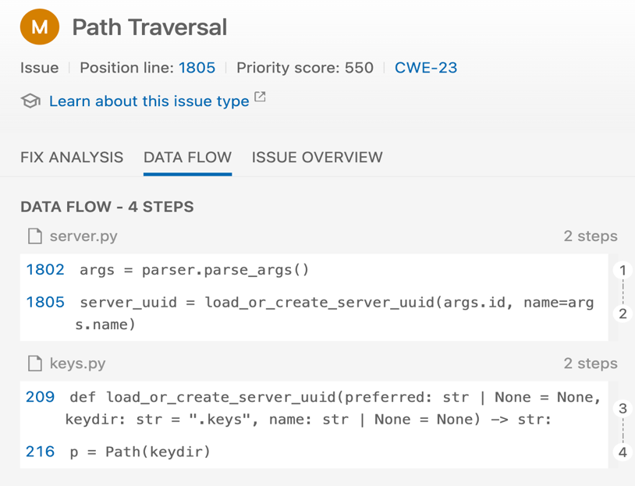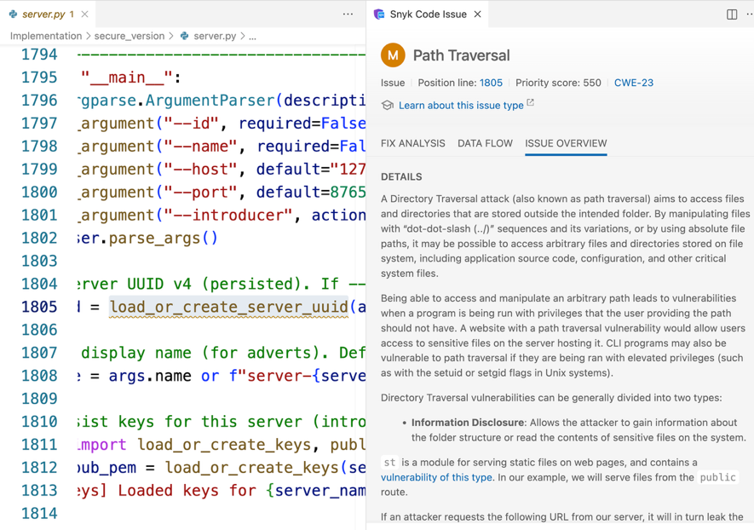

Figure 2: Path Traversal flag

Figure 2: Path Traversal data flow

**Snyk Dependency Analysis**

Snyk also flagged a Missing Report of Error Condition vulnerability (CVE-2024-12797, CWE-392) in the dependency cryptography@43.0.0, introduced through secure_version@0.0.0. Rated CVSS 6.3, this issue could cause TLS clients using Raw Public Keys (RPKs) to overlook authentication failures, potentially enabling a man-in-the-middle attack. Notably, this vulnerability was inadvertently introduced when an AI tool (Copilot) generated the project’s requirements.txt, highlighting a limitation of current AI-assisted development in selecting secure dependency versions. As shown in Figure 3, Snyk flagged the affected module and provided details. The vulnerability was resolved by upgrading to cryptography==46.0.0, ensuring proper reporting of authentication failures and maintaining compatibility with existing encryption mechanisms. This fix secures TLS and DTLS communications across all environments.

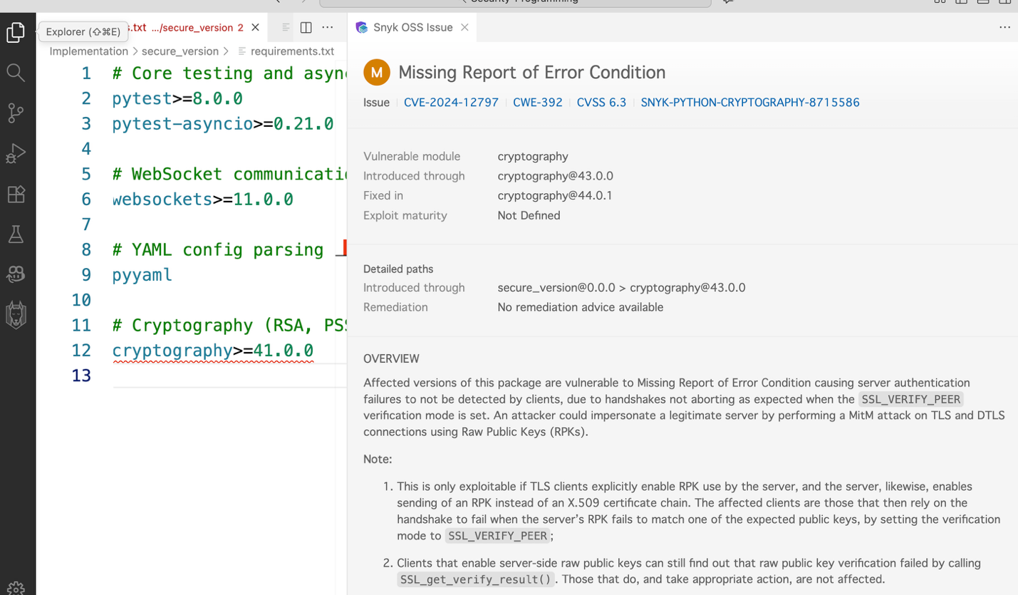

Figure 3: Snyk report

**Conclusion:**All tests in the suite passed, confirming that secure_version enforces proper key sizes, input sanitization, signature verification, and SQL parameterization. Bandit reported no high-severity issues. The code demonstrates robust defensive practices, and the applied patches address identified vulnerabilities. Continuous monitoring, secure dependency management, and integration of automated security checks are recommended to maintain this high level of security over time.